**­­­**

Class 7

**Lecture 13**

**HTML**

**Introduction to HTML**

**HTML**



**Lab Objectives:**

* What is HTML?
* HTML Structure.
* Uses of HTML

**What is HTML?**

HTML stands for ‘Hyper text markup language’. Hypertext Markup Language is the standard markup language for creating web pages and web applications. HTML is widely used to create web pages, develop the content and design the web pages.

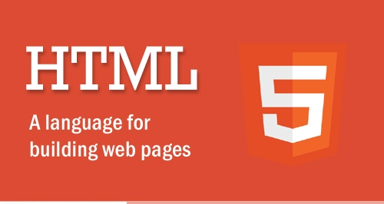

**Version**

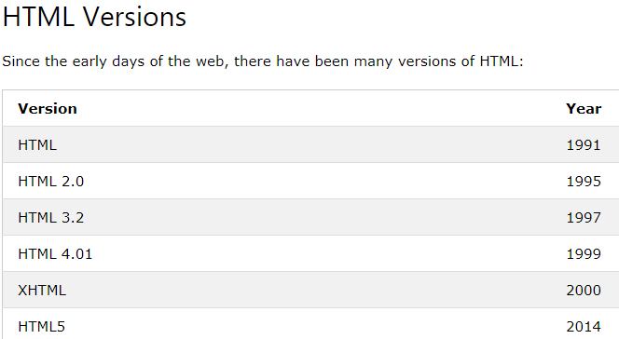

**HTML Benefits**

HTML is the best language for website creation. It's several benefits a number of them are:

* A significant benefit of HTML it is free of charge and no need to install any software.
* HTML is simple to use and understand. and high speed loading time.
* All browsers support HTML.
* Most development tools whatever they are paid or free all support HTML.
* HTML and XML syntax is extremely similar.

**Role of HTML in a web page**

While designing website-we write,format text by using html. see this layout of a web page where the content of each and every portion will be write by using HTML.

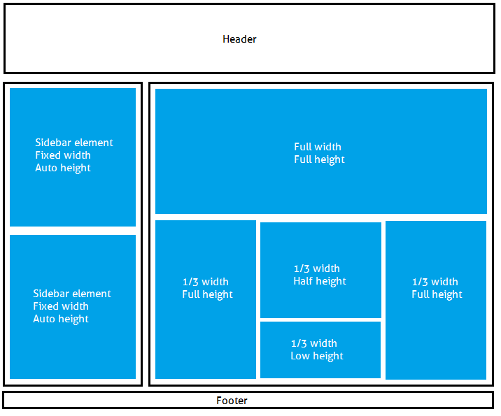

**Sample webpage using HTML.**

**Example 1**:

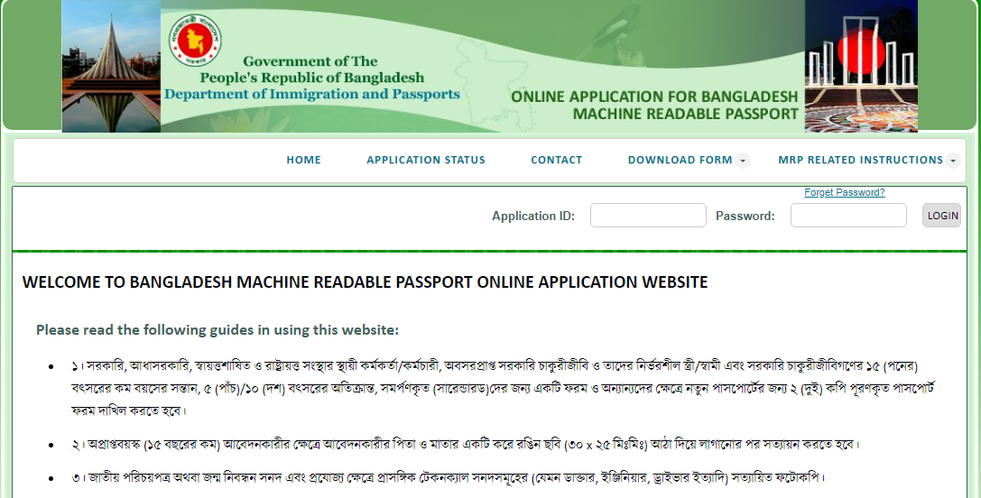

**Example 2**:

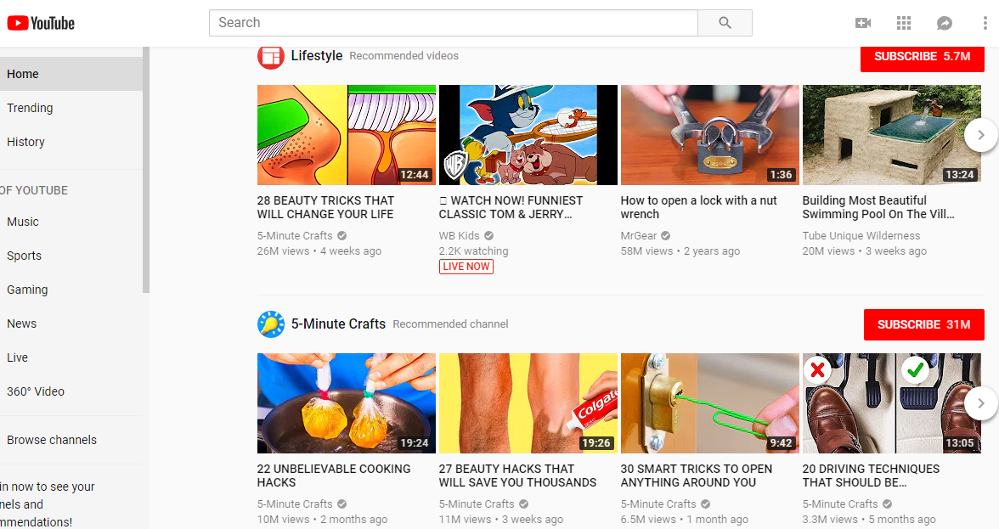

**Example 3**

